**INDIAN STATISTICAL INSTITUTE**



***ASSIGNMENT of STATISTICS:***

***Multivariate Analysis***

**NAME:** SUBHRAJYOTY ROY

**ROLL:**  BS-1613

**COURSE:** B.STAT YEAR- I

**SUBJECT:** STATISTICAL METHODS II

# Introduction

In real life problems, most of the time, the unknown dependent variable seems to be dependent on more than one or two independent variables (or predictors). Hence, to analyze such a situation and relation between those variable we need multivariate analysis.

In ISI, the student is graded in both the mid-semestral exam and the semestral exam and the composite score is taken as the weighted average of the scores in those exams. Most of the university grades their students along these rules, but have different weightages on each part of the examinations. In this assignment, I merely go in the reverse direction to predict how these weights are carefully chosen.

# About the Data

The Dataset is taken from a university in USA, where all the students are taken from a chemical engineering course. I have collected it from [www.openmv.net](http://www.openmv.net) .

There are six variables, including the one dependent variable i.e. the performance in first year Final examination in college, which I want to predict about. The predictors are the grades of their assignments (Practical), Midterm examination, Problem sheet and homework, performance in Tutorial classes and their GPA awarded in high school. Clearly, this will have some effect on their performance in Final examinations.

As the grades are averaged from all the seven papers of the course and scaled down to a ratio to 100, a linear model is supposedly a good fit for the dataset.

# The Univariate Analysis

The univariate analysis on the data is performed and here are the important features of the dataset, as given below:

|  |  |  |  |  |  |  |
| --- | --- | --- | --- | --- | --- | --- |
| **Variable Name** | **Minimum** | **Median** | **Maximum** | **Mean** | **Standard deviation** | **Coefficient of Variation** |
| *School GPA* | 4 | 8 | 8 | 7.316 | 0.93698 | 12.7% |
| *Homework* | 14.09 | 73.30 | 90.74 | 67.84 | 19.5364 | 28.7% |
| *Assignments* | 23.45 | 75.08 | 84.02 | 71.62 | 10.4105 | 14.5% |
| *Tutorial* | 28.41 | 78.03 | 93.82 | 74.72 | 12.7681 | 17.1% |
| *Midterm* | 23.43 | 58.33 | 91.67 | 57.11 | 16.6929 | 29.2% |
| *Final* | 23.38 | 55.32 | 90.74 | 57.12 | 15.7148 | 27.5% |

From the above univariate analysis of the dataset, it seems that the coefficient of variation of Midterm and Final exams are pretty close. Also, their mean matches approximately. This makes us suspicious that midterm marks may significantly affect the final scores of the students. The relation between final scores with other variables are not eminent, but will show up as we do bivariate and multivariate analysis.

# The Bivariate Analysis

The very first feature of bivariate analysis is to find how these variables depend on each other and finding out their respective pair-wise correlation coefficient. This will also help to gather more information about how much interdependence the independent variables have, and also how much each of the independent variable affects the dependent variable (i.e. the scores in Final examination).

|  |  |  |  |  |  |
| --- | --- | --- | --- | --- | --- |
| **Variables** | **School GPA** | **Assignment** | **Tutorial** | **Midterm** | **Homework** |
| **Assignment** | 0.0484 |  |  |  |  |
| **Tutorial** | 0.4345 | 0.4590 |  |  |  |
| **Midterm** | -0.0586 | 0.2007 | 0.1486 |  |  |
| **Homework** | -0.0689 | 0.4832 | 0.2381 | 0.4271 |  |
| **Final** | 0.0881 | 0.2863 | 0.2398 | 0.7244 | 0.4742 |

From the above correlation matrix, it can be seen that School GPA has extremely low effect on Final scores in their first year marks in college, which is quite surprising as it is always assumed that a good student would perform good in school and as well as in college. Moreover, the gap between those two standards are of merely one year.

Also, it is observed that Midterm and Homework are moderately correlated with the final scores, so it may be a good idea to take them as independent variable in the multivariate model to analyze the dependent variable. I also take Assignment and Tutorial with them to see whether the amount of explained part of final scores increases or not.

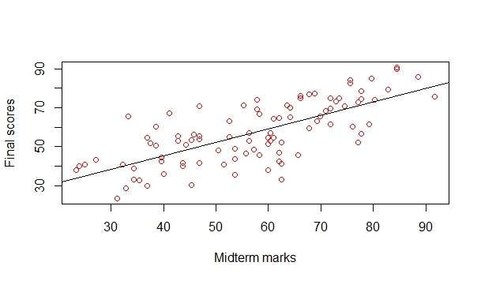 Here are a few scatter plots showing the relationship between the variables:

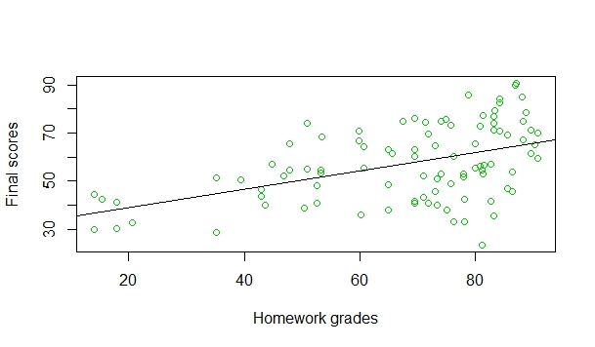

As expected, both the midterm marks and Final scores range over the same interval, following similar trend, as reflected in the scatter plots.

From the scatter plot between Homework grades and final scores, it is seen that most of 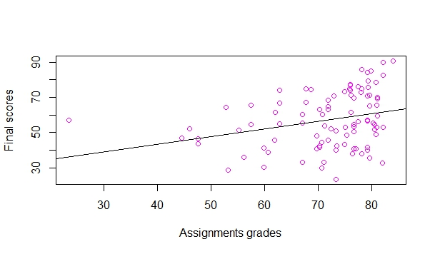the datapoints lie in the homework grades above 70. It may be assumed that this gathering one a single side makes the correlation coefficient not to be reflected as a true measure of relationship between those two variables.

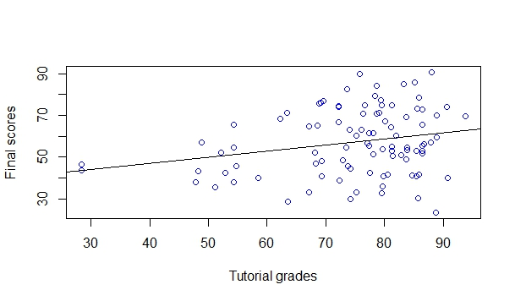 Here are the scatter plots showing the relationship between final scores in the exam with Assignment and Tutorial Grades respectively. It is seen that both of this relationship is somewhat weak.

I also tried to analyze why School GPA had so little effect on the final scores in first year exam, and the reason behind this unexpected thing is cleared by the plot below.

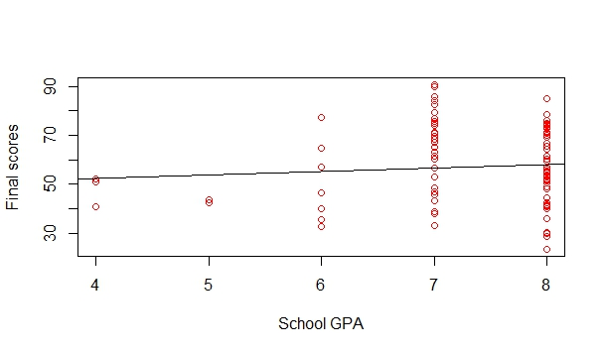

Clearly, School GPA’s are awarded to the students in whole numbers, while after averaging out the final scores of a student over all the papers in first year, the average takes all sorts of different scores up to tenth’s place after decimal. This makes the relationship between the variables to be so lower.

By the above analysis, to some extent it can be expected that taking School GPA as a linear predictor of the final scores is not a good idea. Hence, I will perform the multiple regression analysis with the exception of School GPA.

# Multivariate Analysis

**The Ideal Situation:**

To perform multiple regression analysis, we assume a linear model satisfying the following properties:

1. $Y_{i}=β_{0}+β_{1}X_{1i}+β_{2}X_{2i}+…+β_{p}X_{pi}+ϵ_{i}$, where $X_{1}, X_{2},…,X_{p}$’s are the predictors and $ϵ_{i}$’s are the errors.
2. We assume that $ϵ_{i}\sim N(0, σ^{2})$ i.e. a normal distribution with mean 0 and variance $σ^{2}$.
3. Each of the predictors have their respective correlation close to 0, i.e. the predictors are linearly independent.

Using R, I have created four predictors with 100 many data points. The predictor variables are generated independently from different distributions. Then the errors are generated from a normal distribution with mean 0 and variance 25. Y is computed according to the formula given above and then on the whole set of data points, multiple regression analysis is performed to see how things behaves in case of the ideal situation.

The correlation matrix of the variables is given below:

|  |  |  |  |  |  |
| --- | --- | --- | --- | --- | --- |
| **Variables** | **Y** | **X1** | **X2** | **X3** | **X4** |
| **X1** | 0.5817 |  |  |  |  |
| **X2** | 0.3316 | 0.0790 |  |  |  |
| **X3** | 0.8568 | 0.0236 | 0.00075 |  |  |
| **X4** | 0.0589 | 0.0538 | 0.0387 | 0.0201 |  |
| **e** | 0.2876 | 0.0359 | 0.1028 | 0.1446 | 0.0677 |

Performing the multiple regression analysis on y with respect to x1, x2, x3 and x4, we get the following linear combination as the regression subspace;

**Y = -1.3572 + 0.9971 x1 +1.0481 x2 + 1.0264 x3 + 5.9080 x4**

After performing this regression, the following features of the data is found to come out:

1. Multiple R squared: 0.9821
2. Adjusted R squared: 0.9814
3. F statistic: 1304 on 4 (due to regression) and 95 (due to residuals) degrees of freedom.
4. Residual Standard Error: 5.048 on 95 degrees of freedom.
5. The following table is generated to provide the summary for the coefficients of the linear model;

Coefficients:

Estimate Std. Error t value Probability (>|t|)

(Intercept) -1.35722 1.14574 -1.185 0.239

x1 0.99708 0.03681 27.084 <2e-16

x2 1.04807 0.04815 21.767 <2e-16

x3 1.02636 0.01879 54.628 <2e-16

x4 5.90802 8.08299 0.731 0.467

1. For the residuals, we have the following summary;

Residuals:

Min 1Q Median 3Q Max

-11.6311 -3.5176 -0.2039 2.9058 12.5863

With the standard deviation of the residuals being **4.94**.

1. The ANOVA table for this case becomes the following;

Analysis of Variance Table:

Response: y

Df Sum Sq Mean Sq F value Pr(>F)

x1 1 45790 45790 1796.9150 <2e-16

x2 1 11073 11073 434.5119 <2e-16

x3 1 76069 76069 2985.1329 <2e-16

x4 1 14 14 0.5342 0.4666

Residuals 95 2421 25

1. Here is the corrected ANOVA Table reflecting the regression sum of squares (SSR) and residual sum of squares (RSS) contributing the total corrected sum of squares.

|  |  |  |  |
| --- | --- | --- | --- |
| **Variables** | **Degrees of Freedom** | **Sum squared** | **Mean squared** |
| **Regression** | 4 | 132946 | 33236.5 |
| **Residuals** | 95 | 2421 | 25 |
| **Total** | 99 | 135367 |  |

1. The residual plot between the residual and the fitted values is given below:

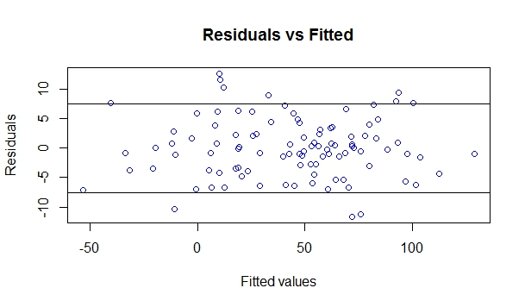

From the above plot, one can see that about 90% of the data points lie in the interval $(-1.5*σ, 1.5*σ)$. About 95% of the data points lie in the interval $(-2*σ, 2*σ)$, where $σ$ is the standard deviation of the errors assumed in the linear model. Also, in the ideal case, as the theory suggests there is not certain pattern in the residual plot, as if the points are distributed randomly over the whole range.

Here is given the individual residuals plots for each predictors;

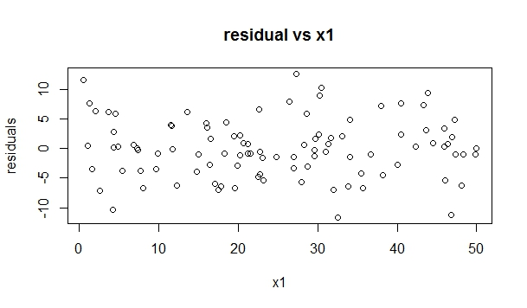

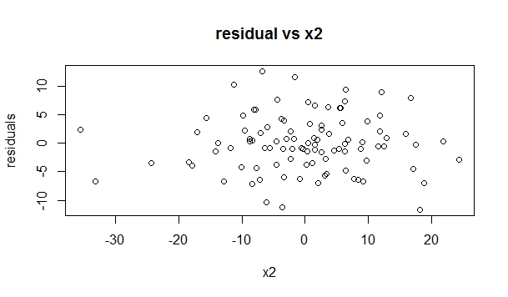

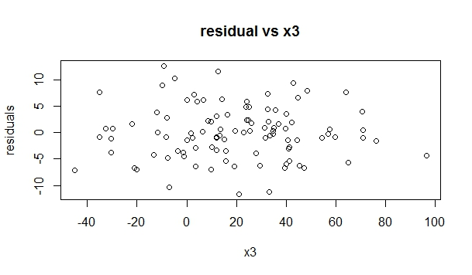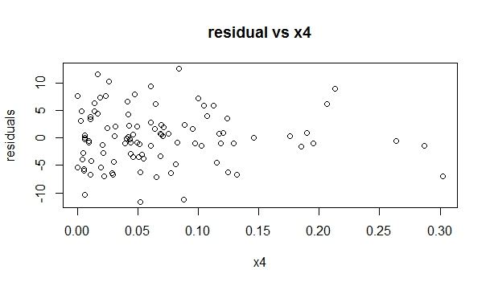

Most of the residual plots are almost similar to that of ‘Fitted’ vs ‘Residuals’ plot, except the variable x4, as it came from an exponential distribution.

Here are the partial correlation found between the dependent variable and the independent ones, removing the effect of the rest.

|  |  |  |  |  |
| --- | --- | --- | --- | --- |
| **Partial Correlation** | **X1** | **X2** | **X3** | **X4** |
| **Y** | 0.949249 | 0.912678 | 0.984453 | 0.074781 |

By the above partial correlation, it seems apparent that these factors indeed controls (to some extent) the value of the dependent variable. Also, the 4th variable is generated from an exponential distribution that shows a really low level relationship between normal and exponential distribution.

Now, after performing the multiple regression on the actual dataset, we can compare the result with the result of the ideal situation and based on that one can analyze the multivariate data.

**Analysis of the Dataset:**

The similar features that are found after regressing Final scores with all the independent regressors like School GPA, Assignments and Midterm marks etc. are given below:

1. The regression equation is as follows;

**Final = -11.36494 + 2.10736* School GPA + 0.08453* Assignment + 0.02727* Tutorial + 0.61906* Midterm + 0.14182* Homework**

1. Multiple R squared: 0.5811
2. Adjusted R squared: 0.5576
3. F -statistic: 24.7 on 5 (due to regression) and 89 (due to residuals) degrees of freedom.
4. Residual Standard Error: 10.45 on 89 degrees of freedom.
5. The summary of the linear model is given by the table as follows:

Coefficients:

Estimate Std. Error t value Pr(>|t|)

(Intercept) -11.36494 11.42154 -0.995 0.3224

School GPA 2.10736 1.31517 1.602 0.1126

Assignment 0.08453 0.13033 0.649 0.5183

Tutorial 0.02727 0.10807 0.252 0.8014

Midterm 0.61906 0.07348 8.425 5.8e-13

Homework 0.14182 0.06860 2.067 0.0416

1. For the residuals after performing the multiple linear regression, we have the following summary;

Min. 1st Qu. Median 3rd Qu. Max.

-27.5100 -8.2970 0.8203 6.7510 26.490

with a standard deviation of **10.17039**.

1. The ANOVA table for this regression analysis is given below;

Analysis of Variance Table:

Response: Final Scores

Df Sum Sq Mean Sq F value Pr(>F)

School GPA 1 180.5 180.5 1.6521 0.20201

Assignment 1 1850.8 1850.8 16.9415 8.595e-5

Tutorial 1 226.7 226.7 2.0752 0.15322

Midterm 1 10765.7 10765.7 98.5434 4.533e-16

Homework 1 466.9 466.9 4.2739 0.04161

Residuals 89 9723.1 109.2

1. The partial correlations between the final scores and the independent factors are given below in a table:

|  |  |  |  |  |  |
| --- | --- | --- | --- | --- | --- |
| Partial Correlation | School GPA | Assignments | Tutorial | Midterm | Homework |
| Final Scores | 0.16745 | 0.06859 | 0.02673 | 0.66610 | 0.21405 |

1. Here is the ANOVA table reflecting the contribution of SSR and RSS as shown below;

|  |  |  |  |
| --- | --- | --- | --- |
| **Variables** | **Degrees of Freedom** | **Sum squared** | **Mean squared** |
| **Regression** | 5 | 13490.4 | 2698.08 |
| **Residuals** | 89 | 9723.1 | 109.24 |
| **Total** | 94 | 23213.5 |  |

1. The residual plot between the fitted values and the residuals are given below;

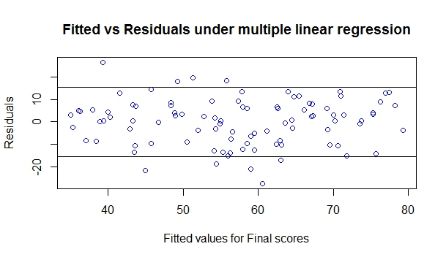

where the two horizontal lines are the bounds for the interval $(-1.5*σ, 1.5*σ)$, where $σ$ is the residual standard error.

Here is the residuals plot for each predictors;

As seen there most of the points clustered to one side for each of the variables, while in together the residual plot shows no pattern. It may indicate one could try weighted least squares for multiple linear regression and perform the analysis to see the effect of residuals over the whole range.

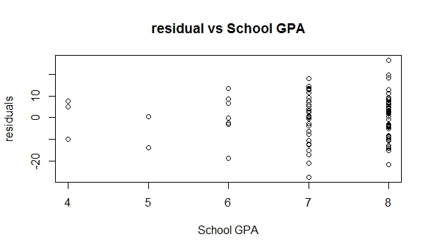

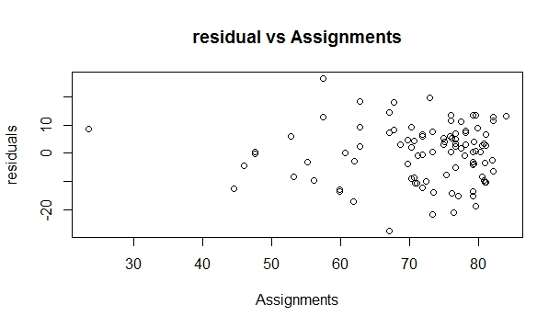

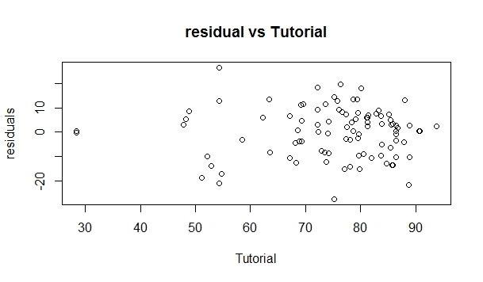

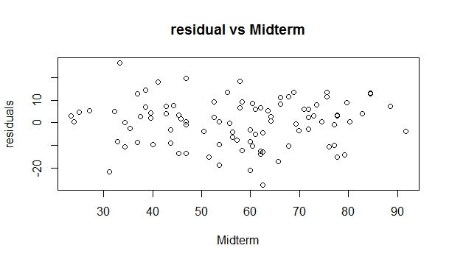

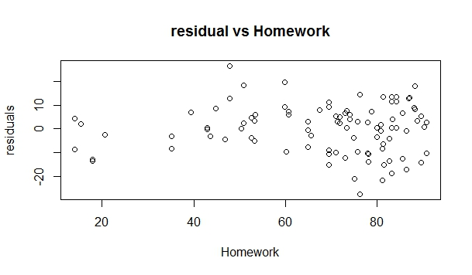

# Conclusion

The following conclusions can be made from the multivariate analysis done on the dataset and by comparing the ideal situation (simulation) with the practical dataset.

* Residual standard error can be expected to be close to the actual errors assumed in the linear model.
* The concentration of points in residual plot should be close to the line “residual = 0”, and the concentration should decrease as one goes away from the line (effectively showing the presence of normally distributed errors).
* Only bivariate analysis fails to give a correct picture of the relationship between two variables as they may be correlated to some other variables (confounding factors). As in the practical dataset, we see that by simple bivariate analysis School GPA was an insignificant factor to predict Final scores, but as it turned out from the partial correlation that it actually has more contribution that it was expected to give. Rather, it was surprising that the other factors that were seemed somehow significant to predict the final scores, have low partial correlation with it.
* School GPA is found to have negative correlation with midterm marks and Homework grades. Obviously, this is not the case as their relationship is being influenced by other several confounding variables.
* School GPA is not a good measure of final scores or their performance, as it is given in terms of whole numbers (or positive integers), hence the close performance in high school gives as lot of students exactly same GPA and this causes unnatural variation along the same line.
* As seen from the regression plots for individual variables, a weighted least square approach to find the regression equation would be more accurate in explaining the model.